Pipeline Master:

Contractor Login:

- Contract shall go the master and click on Pipeline master
- System shall have functionality to upload new records or to view/edit old, uploaded records
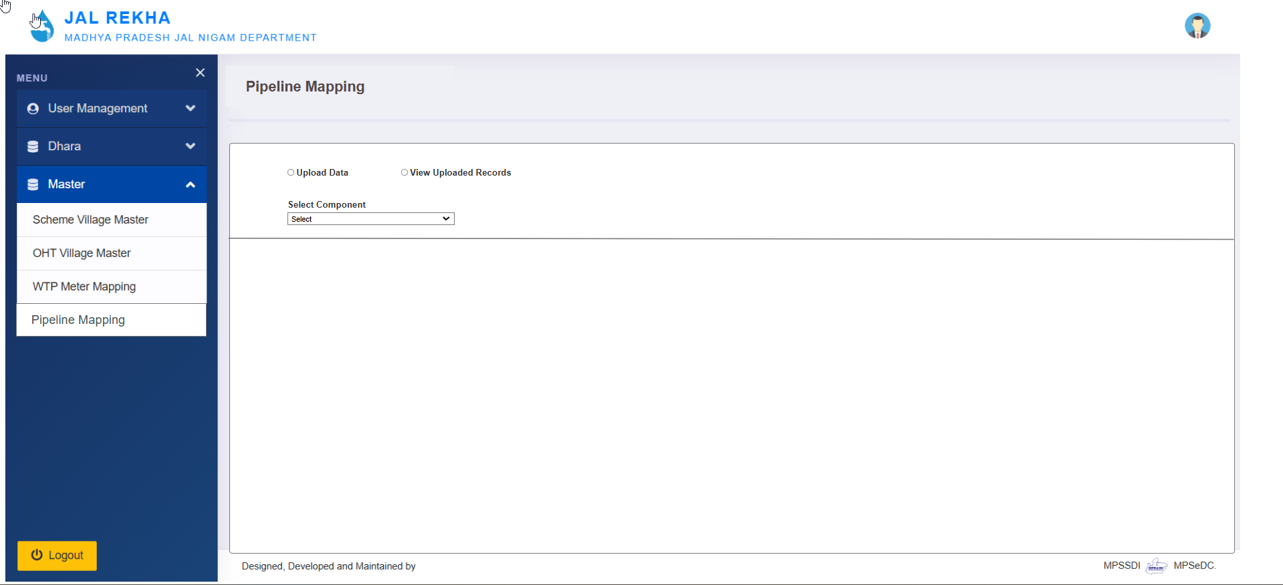
- To upload new records, contractor shall click on “Upload Data” radio button
- Select the component type from the dropdown list. In this list options are “Distribution, CWPM, RWPM, and CWGM.
- Contractor have to upload data in predefine formats, for which templates are available in the portal and can be downloaded for different components
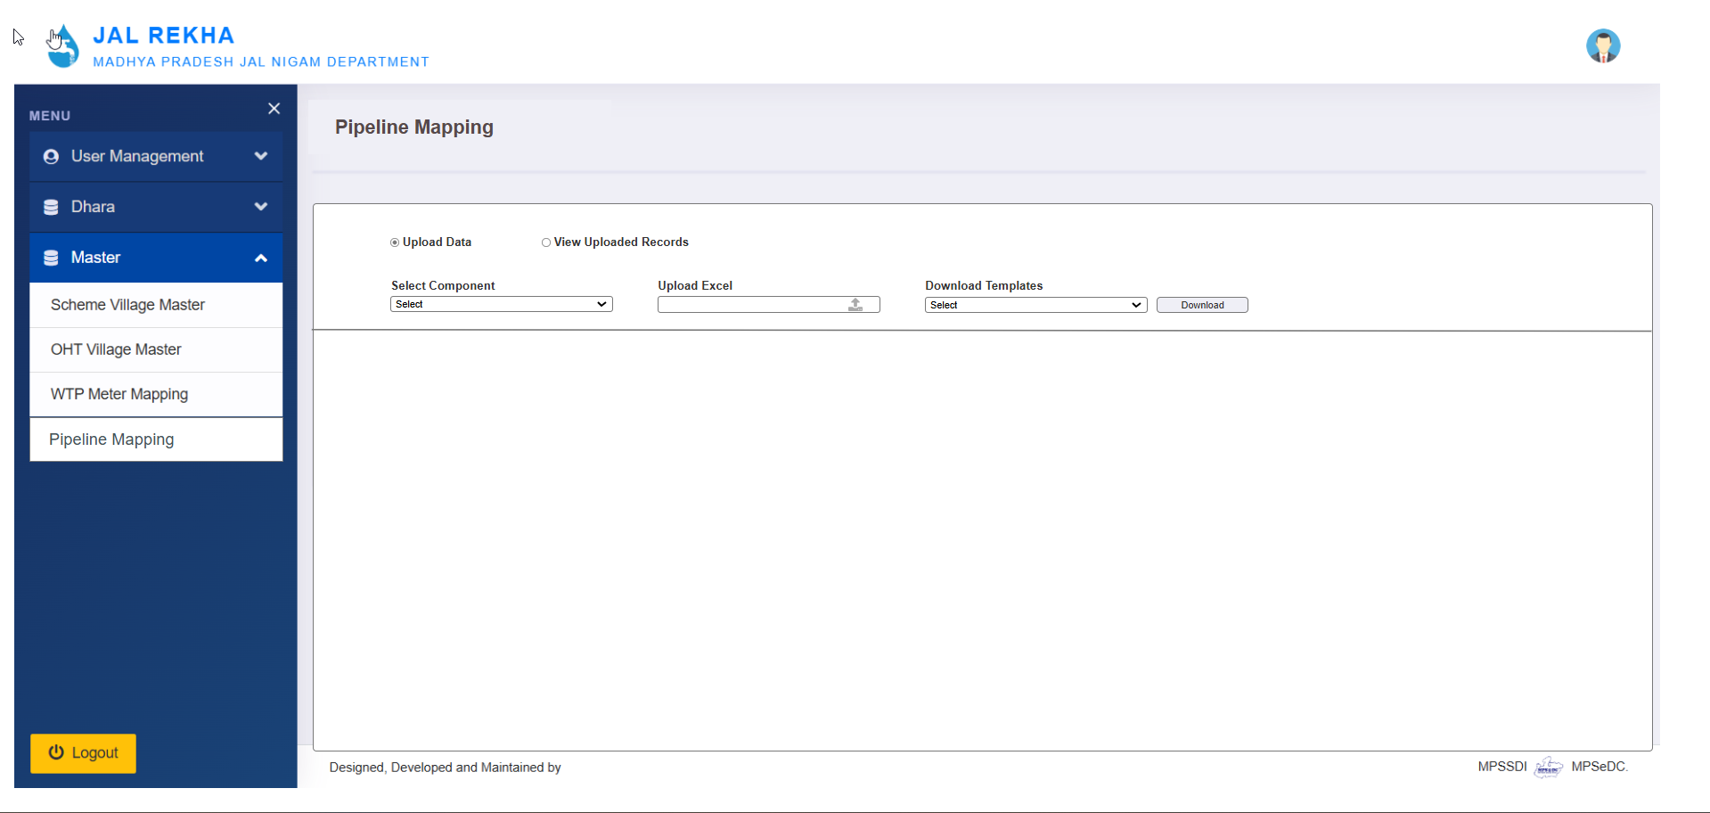
- If contractor need to upload the data for Distribution, need to select “Distribution” from dropdown list.
- On selection of “Distribution” one more field will active “OHT”. Contractor shall select the OHT for which data need to be upload.
- Once the data is uploaded, data shall be visible for review. Contractor shall view all the details before finally submitting it.
- After review details, contractor shall finally “Save” the data or “Discard” and upload again.
- 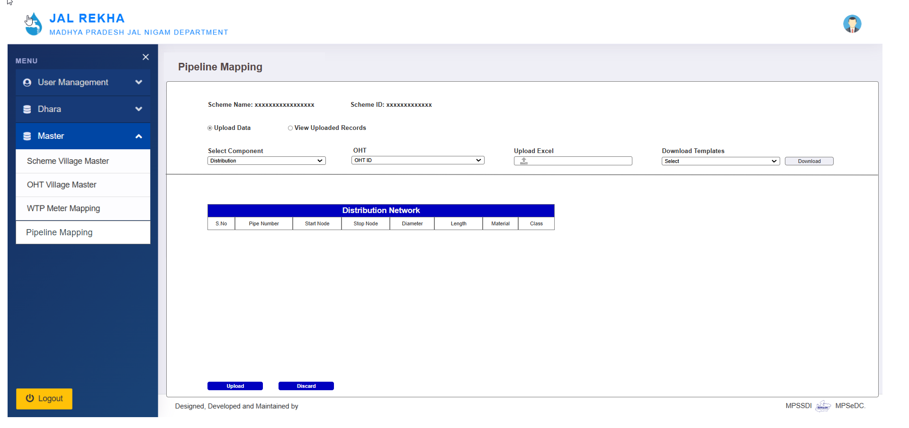
- If contractor need to upload the data for CWGM, need to select “CWGM” from dropdown list.
- On selection of “CWGM” one more field will active “MBR”. Contractor shall select the MBR for which data need to be upload.
- Once the data is uploaded, data shall be visible for review. Contractor shall view all the details before finally submitting it.
- After review details, contractor shall finally “Save” the data or “Discard” and upload again.

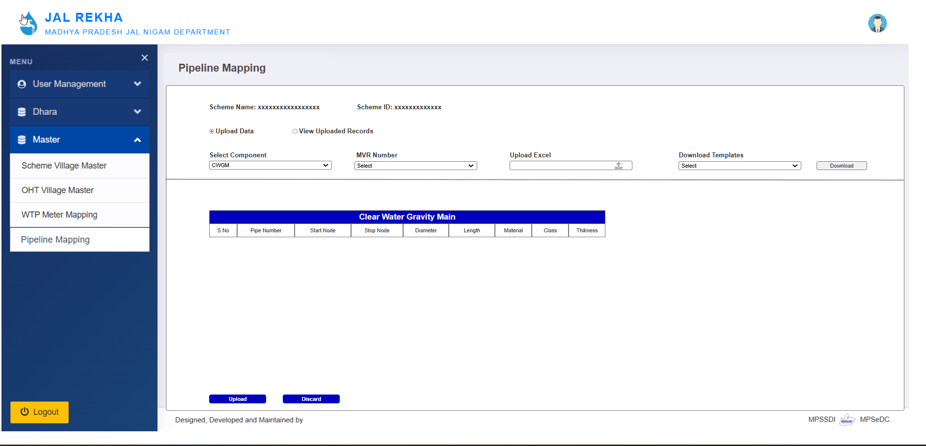
MBR

- For other two component “CWPM” and “RWPM”, need to select “CWPM” or “RWPM” from dropdown list.
- Once the data is uploaded, data shall be visible for review. Contractor shall view all the details before finally submitting it.
- After review details, contractor shall finally “Save” the data or “Discard” and upload again.

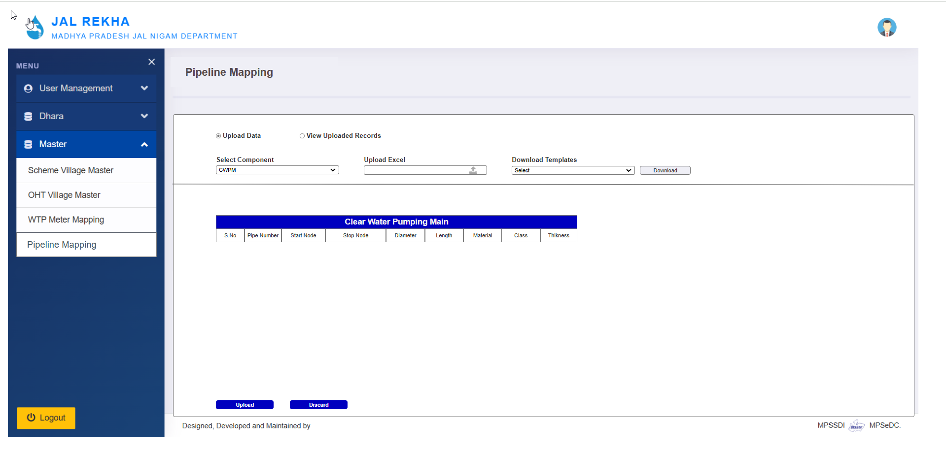

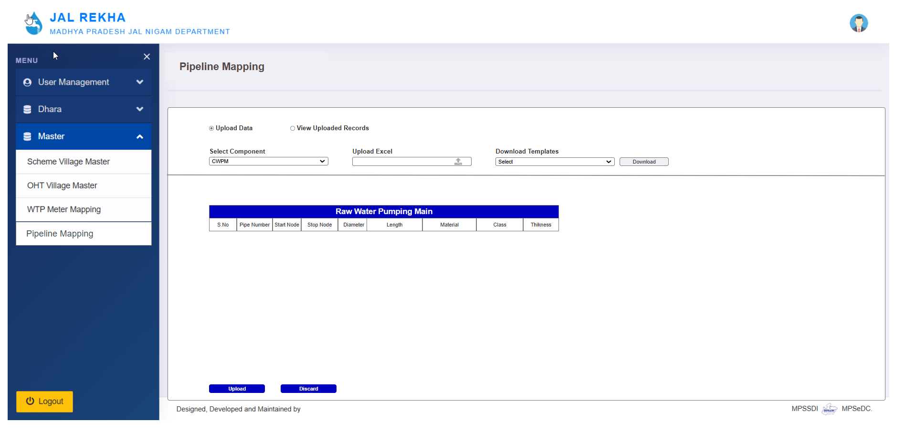

To View Old Uploaded Records

- To view/edit old uploaded records, contractor shall click on “View Upload Records” radio button
- Select the component type from the dropdown list. In this list options are “Distribution, CWPM, RWPM, and CWGM.
- Contractor shall able to edit records or delete records row-wise
- Contractor shall able to delete all records at once by clicking on “Delete All Records”

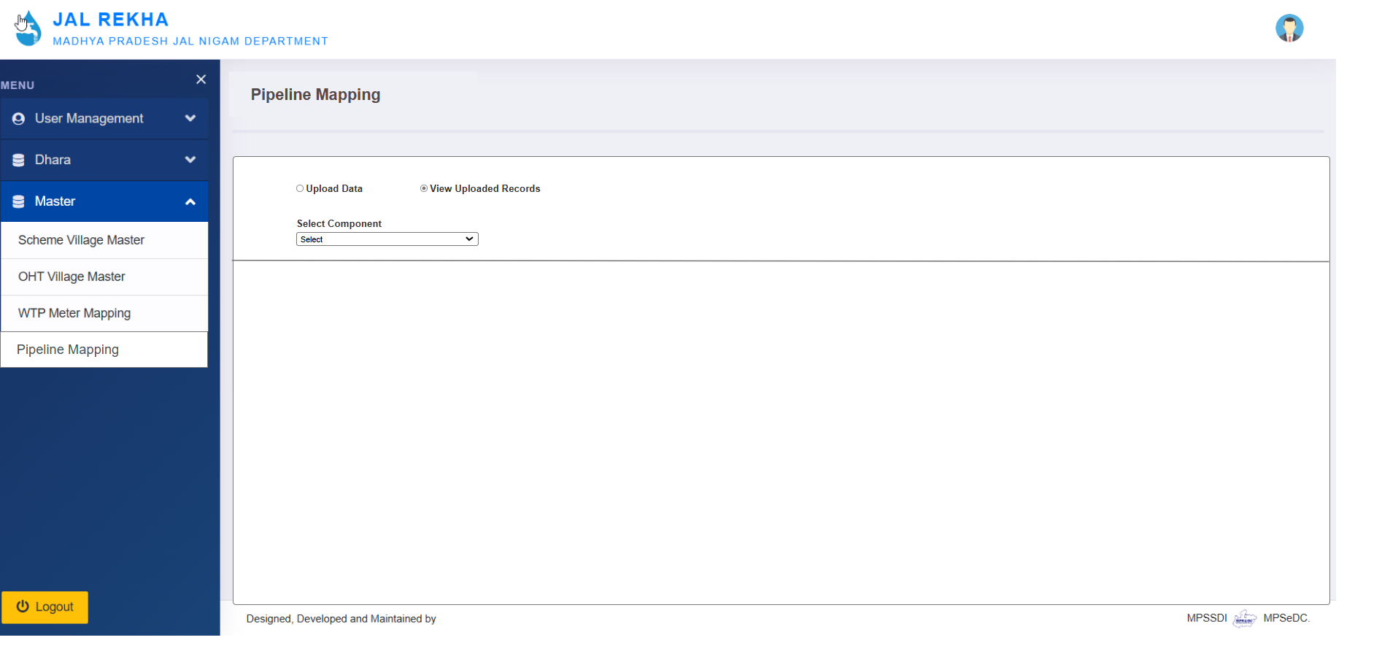

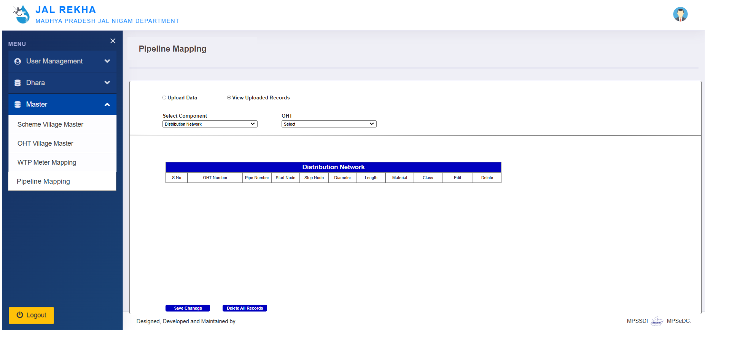

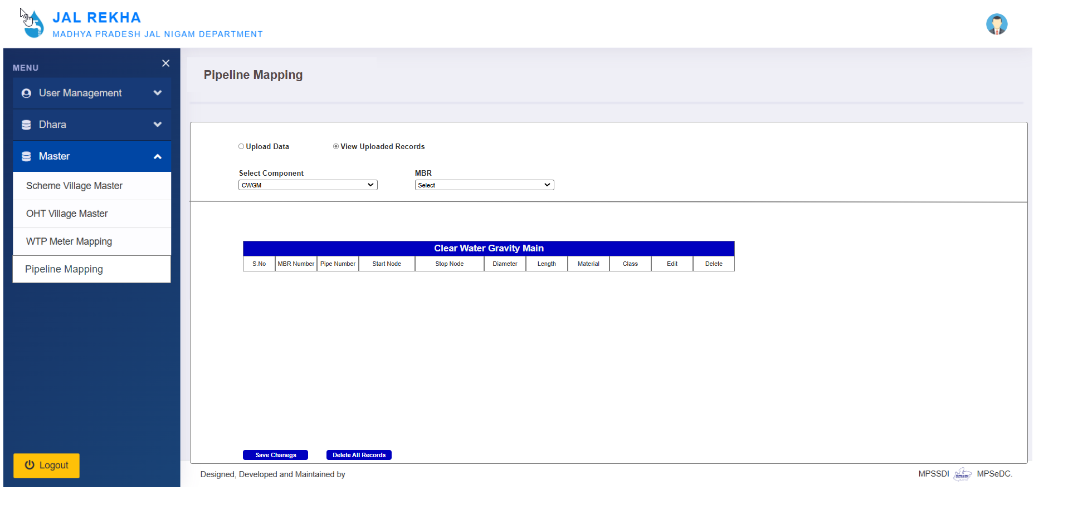

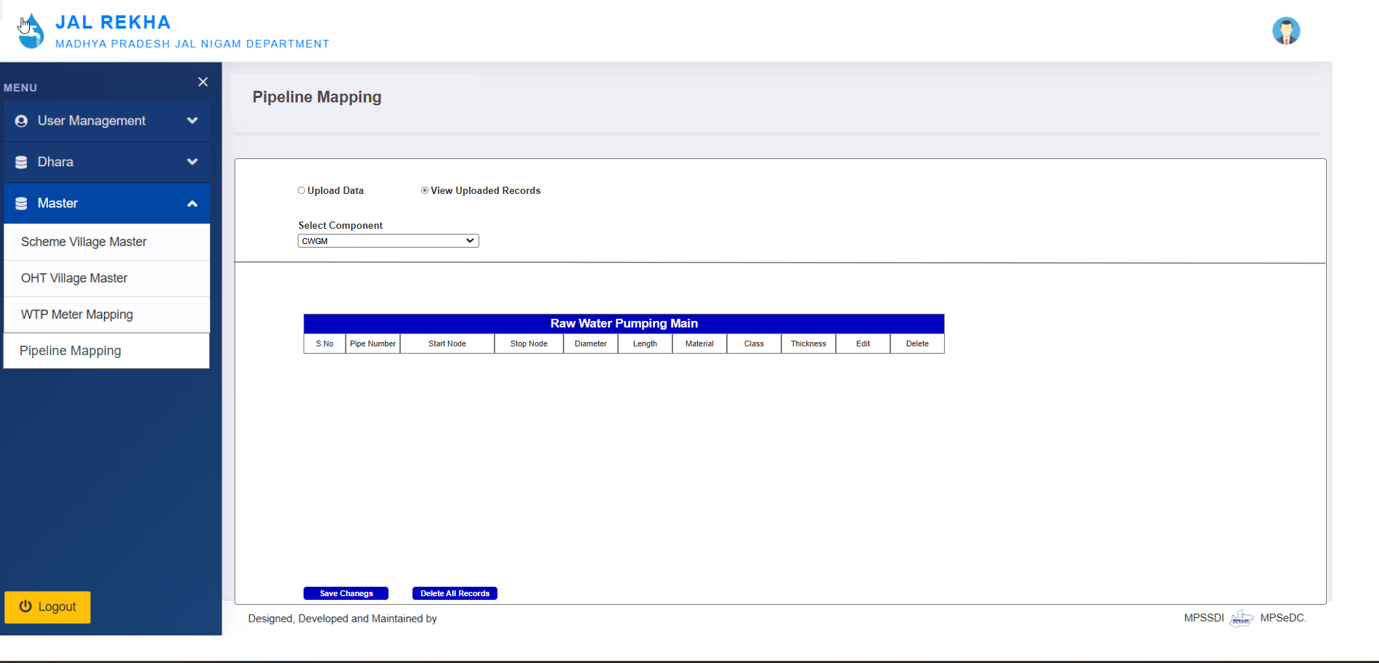

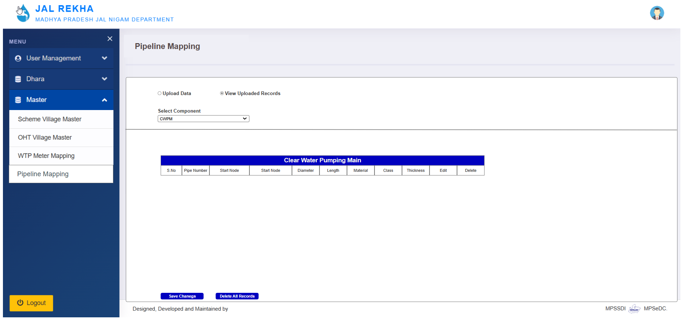

GM Login

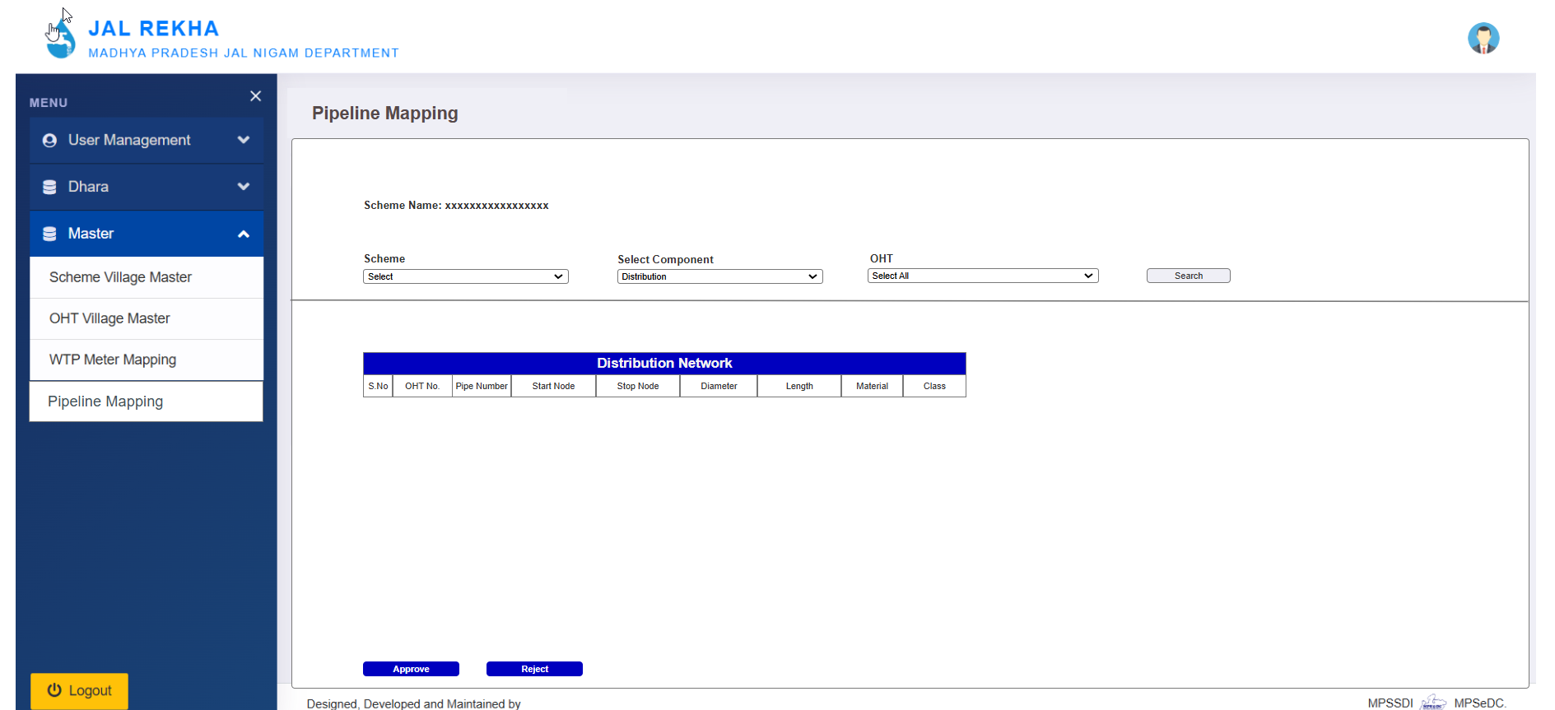
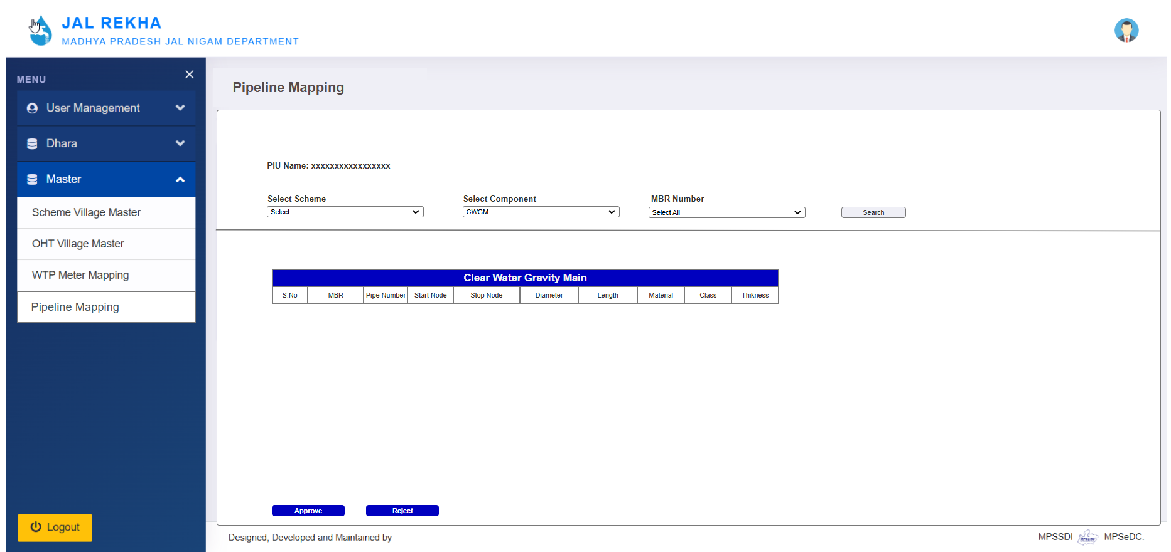

Note: After GM approval, contractor shall not able to delete records

For data validation:
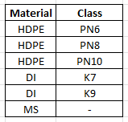
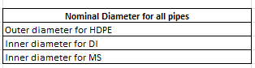
Whole number for length, no decimals.
